# Flux / Met Analysis, MISOBOB 2019 Legs 1 & 2, Aug 2019, BWB

## Overview

### Installation Details

The 2019 MISOBOB and PISTON cruises were conducted on RV Sally Ride (2018 cruise legs were on RV Thomas G Thompson). NOAA PSD wind, motion, T/RH, rain and water vapor sensors were mounted on the small bow mast using a ‘diving board’ extension clamped to the mast just below the ship’s met sensors (Fig. 1). Space on this mast is very crowded and not optimal for good turbulence measurements. See sensor specifics in Table 1.

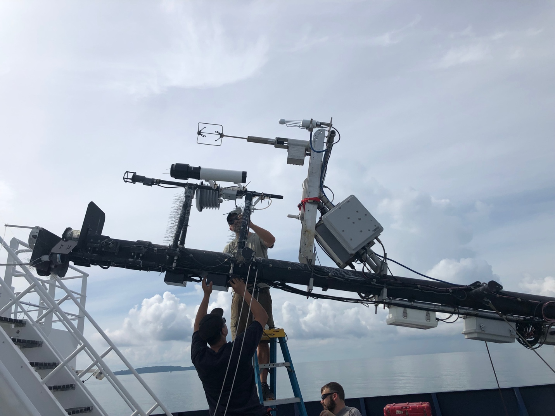

Fig 1: Ship and PSD met sensors at top of bow mast. Mast is lowered for access to sensors. PSD wind, T/RH, rain and fast water vapor sensors are ~ 0.5-1 m lower than the ship’s SCS met instruments.

Ship met instruments included a 2D sonic anemometer, T/RH and pressure sensors, siphon rain gauge and Eppley PIR/PSP longwave and solar radiometers (very top of mast). Other relevant ship measurements included the thermosalinoraph SST/salinity system at 3.5m depth, GPS navigation and heading (Table 2).

NOAA PSD radiometers, GPS/heading system and pressure sensor were attached to the starboard-side railing on the 02 deck just forward of the wheelhouse (Fig. 2). One Eppley PIR (longwave) and two PSP (solar) radiometers were used for MISOBOB Leg 1. One additional Kipp & Zonen longwave radiometer and a Vaisala WXT weather station (T/RH/pressure) were installed at this location for Leg 2. WXT wind data was not used in this project. The NOAA ‘sea snake’ surface SST sensor was deployed from a 2 m boom on the forward port side of the ship.

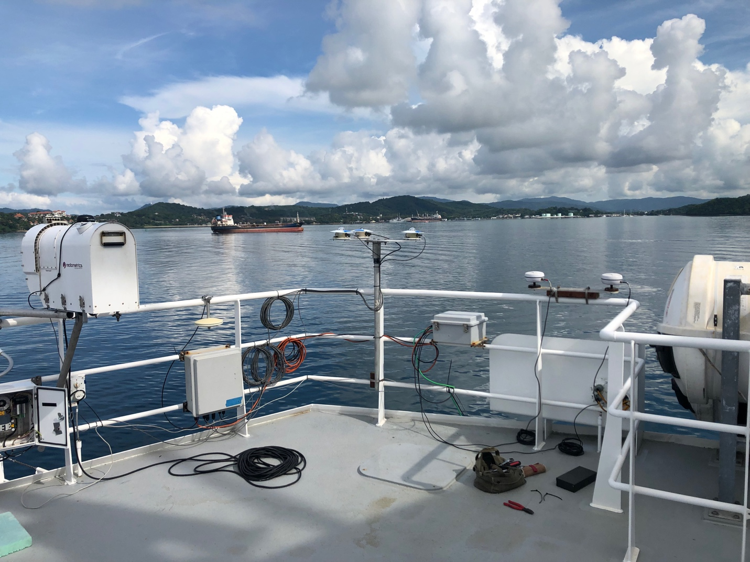

Fig 2: NOAA radiometers (center) and GPS/heading antennas (right) mounted on starboard side forward 02-level railing. The Notre Dame profiling radiometer is on the far left. The NOAA pressure sensor is inside the gray box just to the right of the profiling radiometer.

Table 1: NOAA Met Instruments

|  |  |  |
| --- | --- | --- |
| Instrument | Location (height ASL) | Type |
| 10 Hz 3D Sonic Winds | Bow mast (14.75 m?) | Gill Windmaster Pro |
| 10 Hz 3-Axis Motion | Bow mast (14 m?) | Systron-Donner MotionPak |
| 10 Hz Water Vapor | Bow mast (14 m?) | LI-COR 7500A open path IRGA |
| Air Temperature / RH | Bow mast (13.75 m?) | Vaisala HMT 330 |
| Optical Rain Rate | Bow mast (13.75 m?) | Oregon Scientific ORG |
| Solar Radiometers | 02-deck (8m?) | Eppley PSP (2) |
| Infrared Radiometers | 02-deck (8m?) | Eppley PIR (1), K&Z (1, leg 2 only) |
| Atmospheric Pressure | 02 deck (8m?) | Vaisala PTB220 |
| GPS / Heading | 02-deck (8 m?) | Hemisphere Crescent VS100 |
| Sea Surface Temperature | Focsle deck, forward port side | YSI thermistor |
| Combo met sensor (T/RH/P) | 02-deck (8 m?) | Vaisala WXT520 |

Installation heights for the NOAA bow mast instruments are estimated and should be rechecked at the end of the PISTON cruise leg. Heights for ship sensors are from the SAMOS netCDF files.

Table 2: Ship Met and Nav Instruments

|  |  |  |
| --- | --- | --- |
| Instrument | Location (Height ASL) | Type |
| 2D Sonic winds | Bow mast (15.24 m) | RM Young 86106 |
| Air Temperature / RH | Bow mast (15.24 m) | Vaisala HMP110A |
| Atmospheric pressure | Bow mast (15.24 m) | RM Young 61302V |
| rain rate | Bow mast (15.24 m) | RM Young 50202 |
| solar Radiometer | Bow mast (15.5m) | Eppley PSP |
| infrared radiometer | Bow mast (15.5m) | Eppley PIR |
| Sea surface Temp / salinity | Bow sea chest (–3.5m) | Sea Bird SBE45 |
| GPS Lat Lon | na | Trimble BD982 |
| Heading | na | Hemisphere V104S |

### Data Processing Notes

Cruise data were processed with the NOAA PSD matlab scripts to generate daily first-look QA/QC plots (flux scripts), motion corrected winds, turbulence parameters and 10 min mean met variables (motcorr_flux scripts) and filtered / corrected flux and met parameters at 10-min and hourly timescales (da_red_analysis scripts). Processing codes, raw data, plots and processed data are available by anonymous ftp at:

[ftp1.esrl.noaa.gov/psd3/cruises/PISTON_MISOBOB_2019/](ftp://ftp1.esrl.noaa.gov/psd3/cruises/PISTON_MISOBOB_2019/)

Files with filtered, corrected results are in ~/Sally_Ride/flux/Processed/

PISTON_MISOBOB_2019_flux_10_v4_decorr_**x**_SdS.txt PISTON_MISOBOB_2019_flux_hr_v4_decorr_**x**_SdS.txt

Where **x**=1 or 2 for leg number. For variable names see _10min_flux_file_readme.txt and _hourly_flux_file_readme.txt in the Processed folder.

Turbulence fluxes were processed with the same basic criteria used for the 2018 cruise legs:

* Relative wind direction within +/– 60° of the bow
* Heading standard deviation < 5°
* Ship speed standard deviation < 1.5 m/s
* Standard deviation in platform port-starboard velocity < 0.8 m/s
* Rain rate < 1 mm/hr

Summary plots of met and flux parameters for each leg are in folders ~/Sally_Ride/flux/Processed_Images/da_red_plots_png_**x**_SdS

## Wind

Wind speed and direction measured by the ship and PSD sonic anemometers agree quite well. Monsoon winds were consistently from the southwest but somewhat weaker than during the 2018 cruise legs. Mean wind speeds were 8.4 and 8 m/s for cruise Legs 1 and 2, respectively, compared to 11 and 9.3 m/s for the two 2018 legs. Ship operations in 2019 involved more maneuvering with frequent heading changes compared to 2018 and relative winds were outside the +/- 60° limits more often, reducing the quality of turbulence parameters.

## T/RH

The ship’s T/RH sensor was not functioning properly for much of the project and has not been used in this analysis. For periods when the ship Vaisala T/RH is operating properly on Leg 1 the difference in measured air temperature compared to the NOAA Vaisala is < 0.1°C; the RH measurement is 3% higher compared to NOAA. The WXT weather station installed for Leg 2 has an occasional daytime high temperature bias due to solar heating on the deck. The night time temperature difference with the NOAA Vaisala is < 0.15°C; night time RH is 1.4% lower than the NOAA Vaisala. Differences in RH among the various sensors seem to be within the expected precision of this measurement. For the bulk model flux calculations in this analysis we have used the NOAA Vaisala T/RH throughout.

## Radiation

Solar radiation measurements from the two NOAA PSP radiometers and the ship PSP are generally in very good agreement. On some afternoons, the NOAA PSPs indicate a higher solar flux than the ship PSP. This may be due to reflected sunlight from the ship superstructure affecting the NOAA radiometers mounted on the 02 deck railing. The ship radiometers are in a better location, on top of the bow mast. The ship PSP has been used for downwelling solar radiative flux in the COARE model runs.

Unfortunately, the ship’s PIR longwave radiometer was not functioning properly during either leg. The NOAA PIR1 is the only downwelling longwave flux measurement for leg 1. On leg 2, a second NOAA Kipp & Zonen longwave radiometer was installed on the 02 deck railing (recorded in the dataset as PIR2). At night, PIR1 and PIR2 agree to within a few watts/m2. During daylight, the K&Z radiometer occasionally shows a positive bias of up to 10 W/m2, presumably due to solar heating of the dome (see plots in ~/Raw_Images/IR_flux_2). The K&Z radiometer has no dome temperature sensor; the PIR2 dome temperature variable is set equal to case temperature to compute IR flux (i.e. dome correction is zero). Further processing could correct some of this bias. For now, longwave radiation from NOAA PIR1 is used for COARE bulk model runs.

## SST

The project experienced many difficulties with SST measurements. The ship’s TSG system measurement was not reliable on either leg. The NOAA sea snake functioned until about 0800 hours on day 169. After day 169 the sea snake data are not reliable. Simon installed an RBR temperature sensor on the sea snake during leg 2, beginning from about 1200 hours on day 193. Other leg 2 SST data was obtained with the surf otter and fast CTD. For this analysis, we produced a ‘best’ SST value from available sources:

PISTON_MISOBOB_2019/Sally_Ride/flux/Raw/MISOBOB_2019_SST_best.mat

SST for leg 1 (up to day 169) is the NOAA sea snake, with no further data thereafter. SST for leg 2 is from the RBR sea snake sensor, when available. Other leg 2 gaps are filled by the surf otter and fast CTD when possible. There are several periods of no data on both legs and the bulk model cannot be computed for these periods. The ROSR sensor was used on leg 1 (not on leg 2?) and could be used to fill in some missing data. I have not done that in this analysis. The ROSR data is intermittent and should be carefully compared with the sea snake for all overlapping periods. Using ROSR SST, the COARE bulk model *jcool* option should be set to zero (i.e. the cool skin calculation should be turned off).

## GPS/Heading

The NOAA and ship Lat/Lon/COG/SOG measurements compare well for both legs. Ship data is used for true wind speed and direction corrections in this analysis. The NOAA heading system was not running properly on either leg, so 1 Hz ship heading is interpolated to 10Hz for the wind motion corrections.

## Stress

Based on inspection of variance spectra for U, V and W and cospectra for UW, the wind motion corrections for this project look OK (see plots in folders SpectraPlots_decorr_x_SdS).

Wind stress (or, equivalently, friction velocity & drag coefficient) were determined by covariance and inertial dissipation (ID) methods and also computed with the COARE bulk model for both legs. Measurement results were filtered using quality control criteria above. Additional limits were applied to turbulence parameters to eliminate outliers and to eliminate periods when the sonic anemometer experienced data loss (usually rain events). These additional limits are defined in section 1 of the PISTON_MISOBOB_2019_da_red1_v4_SdS.m processing script.

Stress/ustar/Cd results are summarized in several plots for both legs (see folders da_red_plots_png_x_SdS, plots 35-36, 51-54, 74-77, 80). Covariance and ID methods are generally consistent with each other, but both trend higher than the bulk model with increasing wind speed. This contrasts with results from 2018, when agreement between the stress measurements and bulk model was excellent. The higher levels of wind stress measured in 2019 may be an artifact of flow distortion from the crowded bow mast configuration on Sally Ride noted above.

## Sensible Heat

As in 2018, air-sea temperature differences and sensible heat fluxes were very small, near zero. Direct measurements by covariance or ID are therefore subject to large random error relative to the mean flux. Problems with noise in the sonic temperature spectrum contribute additional bias error. Estimates of the sensible heat flux Stanton Number (from the slope of plot 31) seem too large. The bulk model provides a more reasonable value for sensible heat flux on legs 1 and 2.

## Latent Heat

Water vapor flux measurements were frequently impacted by rain and sea spray on the Licor 7500 optics. The Licor AGC quality control parameter was frequently out of the acceptable range (da plot 27). We therefore have only a limited number of good latent heat flux measurements. However, when the Licor is functioning the humidity data look quite good. Specific and relative humidity computed from the Licor sensor agree very well with the Vaisala T/RH probe (da plot 27) and this comparison is superior to results from the 2018 cruise legs. The computed latent heat fluxes, however, trend high with wind speed compared to the bulk estimate (da plots 40-43, 68-69). This may be due to the flow distortion mentioned above, contributing to bias in vertical wind velocity and ID friction velocity (usib), both which are necessary to derive the covariance and ID latent heat fluxes.

## Heat Budget

Components of the net heat budget were fairly steady during leg 1 and more variable during leg 2, modulated by changes in wind speed, cloud cover and ambient RH (da plot 83). Sensible heat is the least significant term (generally < 5W/m2); longwave radiative heat loss from the ocean was ≅ 30-40 W/m2; latent heat loss (da plot 78), most responsive to wind speed and ambient RH, varied from ≅ 50-150 W/m2. The hourly and daily mean net heat budget from the bulk model is illustrated in da plot 87.